_x005F_x005F_x005F_x005F_x0001_

iOS Integration

Prepared by

version 1.0

Contents

Contents 1
1. DOCUMENT VERSION 1
2. CHANGE HISTORY 2
4. ENVIRONMENTS 3
5. iOS SDK Installation & Transaction Initiation 4
7. APPROVALS 12

DOCUMENT VERSION

This section lists the details of reviews for this document:
Version No. | Name of Reviewer | Role | Date
1.0 | Manish Deshmukh | Manager

2. CHANGE HISTORY

This section details the changes this document has undergone:
Version No. | Details of Change | Changed Sections | Date
1.0 | Base Version
1.1 | Apple Pay Integration

INTRODUCTION

Urway payment integration kit allows merchants to instantly collect payments from their users using various payment modes like credit cards, debit cards, wallet, ApplePay etc. The Urway payment integration supports a seamless payment experience on your platform, while protecting your application from payment frauds and complexity related to various regulations.

ENVIRONMENTS

Urway provides two environments to merchants viz Testing and Production.
The merchant have to integrate with the Urway testing environment first and complete the entire integration and testing process. Once testing is completed, merchants would be on-boarded to production environment.

Merchants need to have an active Urway account to use the test environment and production environment separately. Merchants will have to log in to their Urway Dashboard account and get the API credentials for using these environments. These credentials would include the Terminal ID, Terminal Password and Merchant key details that need to be used for integration.

All transactions initiated by the merchant on the test environment would only be processed with test cards provided for integration. Urway would verify the test logs on its side to ensure the integration is completed as expected. Test environment is strictly for testing the request and response functions.

After successfully testing the integration, merchant would be provided with production credentials & URLs to start acquiring transactions on production environment. These credentials also would be provided by Urway.

iOS SDK Installation & Transaction Initiation

The following environments are used in this development:.
The following environments are used in this development:.
- Xcode 12.2
(2) Minimum Deployment Target 12.1

iOS SDK installation
Open Terminal window,
Move to project root Folder
1. Enter command ‘Pod init’
2. Open Pod File
Add below line to integrate Urway SDK in targets sections:
pod 'Urway', :git => 'https://github.com/URWAYios/UrwaySDK.git
3. Enter command ‘Pod install ’ in command line

Utilization:
In ViewController.swift
1. Import Urway

Initialization :-
Calling Urway payment on Button Click
- UWInitialization.init(self)
By this initialization we have given payment controllers and results of validated mandatory fields.

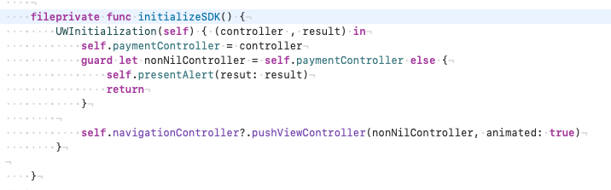

PROTOCOLS:
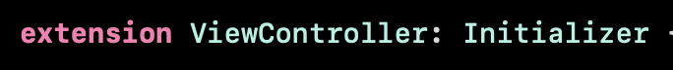
Initializer in ViewController.swift
- prepareModel(). For passing Data from app to plugin
- didPaymentResult(paymentModel , Error). -for check response and showing receipt Page
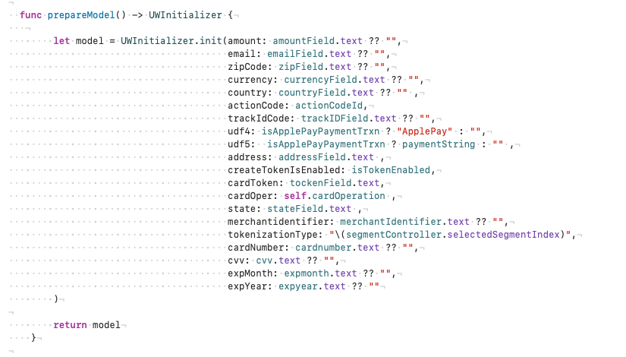

MANDATORY PARAMS :-
1.For Normal Transaction
- Amount , Email , Currency , Country , Action Code , Track Code , tokenizationType
2.For Apple Pay
- Udf4 , Merchant Identifier,udf5,applePa
3.For Tokenization
- DropDown(Add or Update or Delete)
CONFIGURATION FOR CREDENTIALS in ViewController.swift
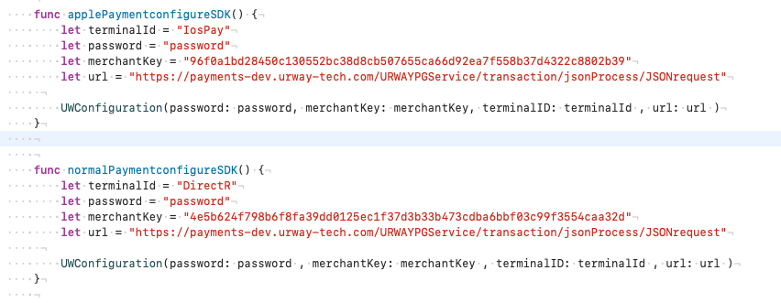
APPLE PAY INTEGRATION:-
- In ViewController.swift
import PassKit
- Apple Pay Button Click
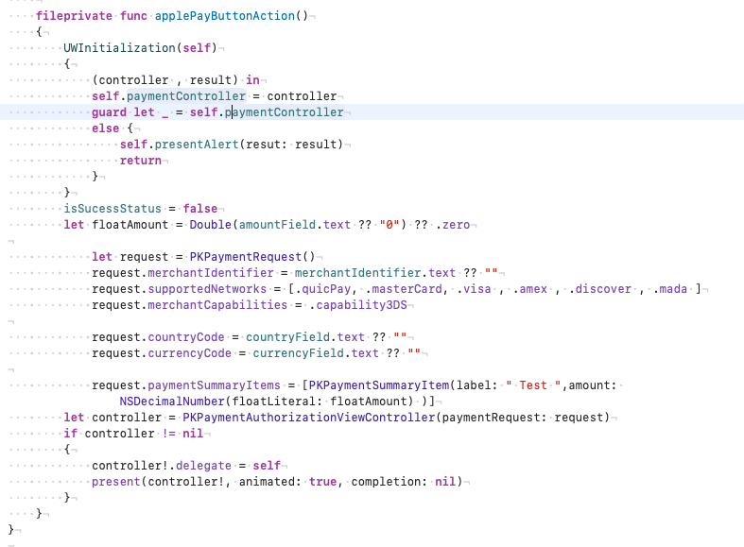

ADD DELEGATE FOR YOUR RESPECTIVE Apple Pay CONTROLLER:-
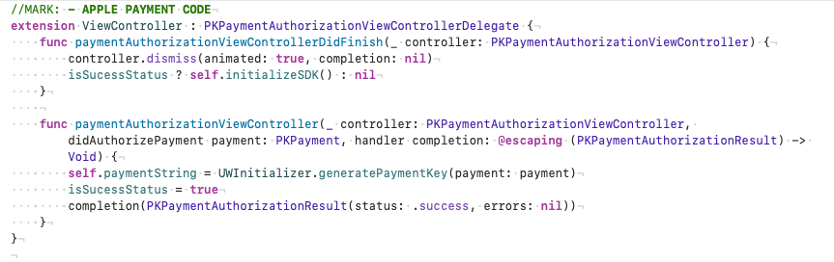

You can get payment String by parse Payment to GeneratePaymentKey() method

Request Paramters
Required parameters to perform transaction.
Sr No | Fileds Name | Mandatory | Description
1 | trackid | Y | Unique TXN order number
2 | instrumentType | N | Value = DEFAULT
3 | customerEmail | Y | Customer Email Id
4 | customerName | Y | Customer Name
5 | action | Y | Type of Transaction to Perform
6 | merchantIp | Y | Ip Address of device
7 | currency | Y | Self-explanatory
8 | country | Y | Self-explanatory
9 | amount | Y | This parameter should contain the payment amount of the particular transaction. Note: Please type-cast the amount to float type Example: 10.00
10 | udf1 | N | User defined field 1 – This parameter has been made for you to keep any information corresponding to the transaction, which may be useful for you to keep in the database. UDF1-UDF5 fields are for this purpose only. It’s completely for your usage and you can post any string value in this parameter. udf1-udf5 are optional parameters and you may use them only if needed
11 | udf2 | N | User defined field 2 – Same description as UDF1(Merchant can pass response URL )
12 | udf3 | N | User defined field 2 – Same description as UDF1
13 | udf4 | N | User defined field 2 – Same description as UDF1
14 | udf5 | Y and N | Y for Apple Pay(pass payment Token)  N for normal transactions. User defined field 2 – Same description as UDF1
15 | MerchantIdentifier | Y | Merchant Id.
17 | CountryCode | Y | Country Code.
18 | CurrenyCode | Y | Currency code.
19 | customerIp | Y | Ip Address of device

Response Parameters

Sr. No | Field Name | Description
1 | Tranid | Unique transaction id generated by gateway.
2 | amount | Transaction Amount
3 | cardToken | Card Token number
4. | Card Brand | Brand of Card
5. | Masked Pan | Masked Card Number
6. | Result | Transaction Result
7. | Response Message | Response Message of Response Code

APPROVALS

 | Name | Team | Date
Prepared by | Manish Deshmukh | Open System | 27/11/2020
Verified by
Approved by

